Avon Little League Board Meeting – 2/19/26 7:40pm

Welcome & Call to Order
- Vote for approval of last month’s meeting minutes - unanimous
- Visual Sports (Russ) came to meeting to communicate improvements to photo day processes and photo products/packages

President’s Report/New Business – Kyle Peters
- Winter Training is going very well - at least 10 high school players showed up every week
  - Missed one session due to weather - T3 issued a refund for one session
- Aaron and Zach from Avon Parks met with Kyle and Renee to discuss the fields for the upcoming season
- City council meetings - Mayor Jensen loves seeing kids at the meetings
- Motion to continue to work with Visual Sports for photos - approved unanimously

VP Baseball Report – Mark Pesta
- Volunteers needed for Minors/Majors Evals
- Need to send out updated rules

VP Softball Report – Jason Ochs
- 103 girls came out for Winter Training
  - High school girls did a great job leading the drills to drive home the progression of skills development
  - 6 core values instilled every week
  - Substantial growth over the course of 5 sessions
- 8 girls signed up for Majors - a few more needed to field an Avon team
- Will organize a free pitching clinic for Rookie and Minors girls prior to the season
  - Coaches will be asked to nominate a handful of girls from each team

Scheduling – Renee Nemeth
- Board members coaching more than one team please text or email me your role and division.
- Coaches clinic for baseball - maybe next year?

Treasurer’s Report – Linda Ochs
- Financial Update
  - ~$173k in the bank - $75k to be given to city
  - Motion for $1000 for pizza warmer for concessions - approved unanimously
  - Separate Non-profit for Emerald Necklace and Thurmon Munson
    - Need to certify as NP before opening bank account

Communications Chair – Josh Fleischer
Enhance campaigns going into the final weeks of registration?
- Social Media posts
- Email continues to appear in St Mary Newsletter
- Holy Trinity never responded to requests
- Can we send out to Avon public schools
When do we start communicating season topics?
- Email to coaches for Manager meeting
- When do we advertise the "Coach the Coaches" meeting

Upcoming Newsletter topics.
- 2026 Spring Registration CLOSES MARCH 1st
- Challenger Division Baseball
- Park and Field Improvements
- Avon City Council Meeting - Little League Showing of Support
- Dunham’s Sports Discount
- Dicks Discount Weekend - March 20th
- 2026 Sponsorship Opportunity
- Avon Little League Opening Day with the Crushers
- Avon Little League Board Meeting
- Follow on Social Media

Player Agents – Josh & Mike
- Spring registration update
- Eval volunteers Needed: March 15 and 22
- Park Improvements Update
  - Avon issued a PO for lights for Vets 1 and 3
  - Midwest Netting will install batting cages
  - LL Park improvements are weather dependent - concrete pouring, etc…
    - All - keep an eye on improvements - Let Kyle know if things stall or are not progressing efficiently
- Discussion to narrow down Majors coaches
Challenger- Tony Hoehler
- 30 signed up so far
- Jerseys are ready to go

Coaching & Culture Coordinator – Ryan Virtue

Safety Officer – Wayne Nicol
- SAFE Plan in progress

Umpire in Chief – Pete Anamasi
- More than 50 kids signed up - need to organize training

Equipment & Uniform Manager – Jonathon Burt
- Vote on getting a dumpster to dispose of old equipment and packaging from new equipment - not needed

Social Media - Brian Langemo
- 1601 FB followers - recent increase of 34
- 87 Instagram followers
- Peak hours tracker found - intending to use to time posts

Website - Mark Jennemann

Sponsorship – Harry Azzano
- 55 Confirmed Sponsors / 39 Officially Registered & Paid
  - 2 Companies said they will make donations and not sponsor
  - 44 already paid
- Ideas To Implement:
  - Team Schedules given to sponsors
  - Sponsor Appreciation Day
  - Sponsors come out on a Saturday game and get to meet with their teams and parents
  - Sponsor Appreciation Mixer
  - Targeting July after Spring Season @ Two Bucks
  - Social Media Plugs
  - Thank You Posts on LL Pages
  - Grouped Together: Banner Only & Silver
  - Individual: Gold & Platinum
- Fundraising Day(s)
  - Chipotle
    - March 25th, 2026, 4pm-8pm
    - 35925 Detroit Rd Avon
    - I sent the board flyers to share with teams, family, friends, and social media
    - MUST use the code: VBRA4ZM (In-Person or Online)

  - BIGGBY Coffee
    - May 17th, 2026
    - BIGGBY Donation Day – Will donate $1 for every cup sold to Avon LL
Board to help advertise
- BIGGBY Coupons
  - Requested to distribute at LL Home Games and have at concession stands
- Dick’s Sporting Goods
  - DSG-Shop Weekend *Weekend of March 20th, 2026 20% off
- Diamond Fundraising Opportunity
  - Fundraising Options
    - Traditional Candy Sale
    - Purchase candy & snacks thru Diamond for concession stands and make additional profit (See attached)
    - $15 School Fundraiser Program | Easy Fundraising
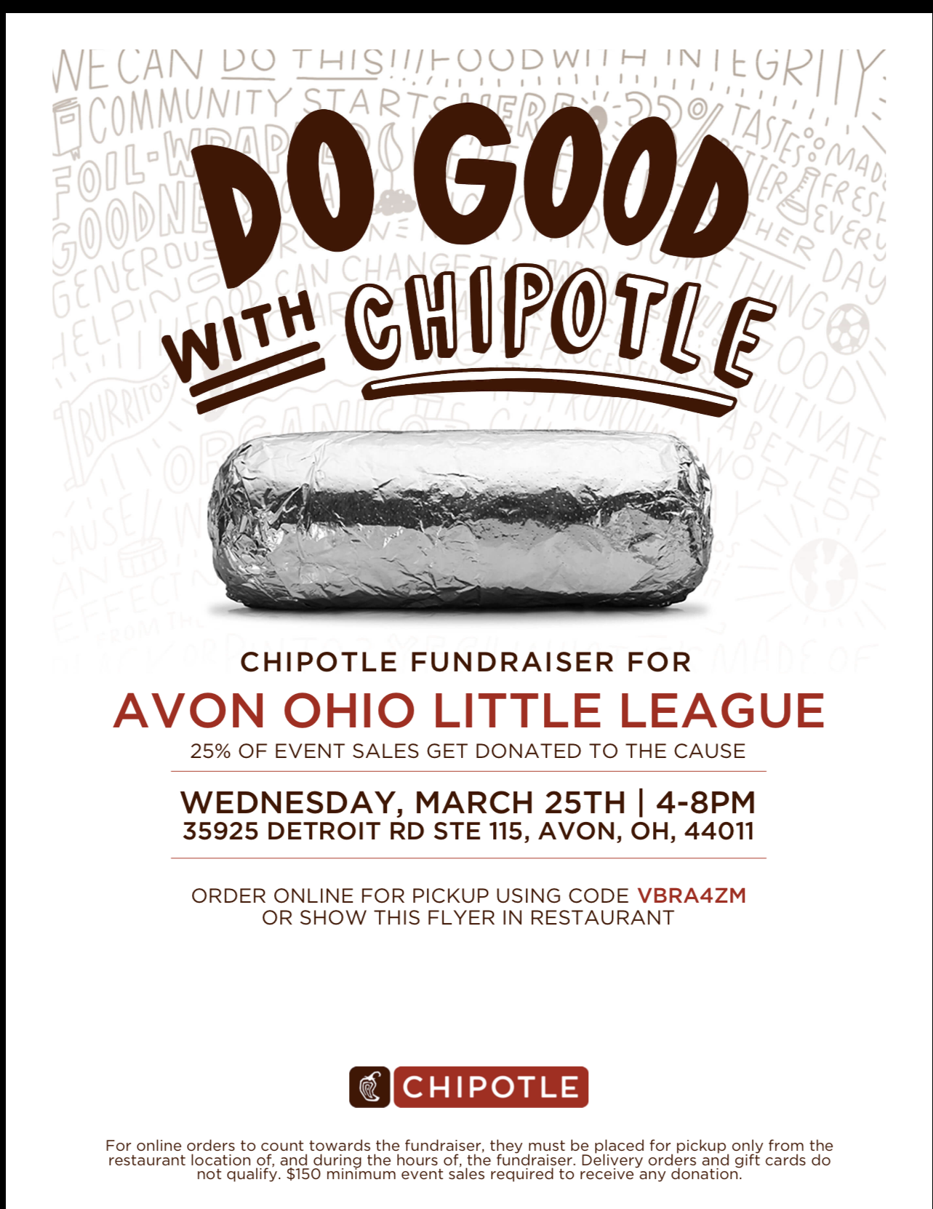

Concessions - Antwaun Armstrong
- Need to order a pizza warmer if LL's stand is going to have one - motion approved unanimously to purchase (Elite Kitchen Supply 24 inch)
- Annual food licenses due 3/1.
- I'm signing up for-two day ServSafe course 3/24 & 3/31. $175 payment due 3/10.
- I have a sample certificate of appreciation for meal donations for the board to see.
- Budget for food and drinks for the season?
- How will shopping work?

GM Updates-
- Majors BB GM - Mike Ramirez
- Minors BB GM - Matthew Love
- Rookie BB GM - Ray Loeser
- Coach Pitch BB GM - Josh Armbrecht
- Tot and Tee BB GM - Derek Wilson
- Minors SB GM - Josh Fleischer
- Rookie SB GM - Jon McKenzie
- Coach Pitch SB GM - Jon McKenzie
- Tee and Tot SB GM - Tony Hoehler
- Challenger - Tony Hoehler

Attendance
Kyle Peters Mike Burcewicz Matthew Love Jonathan Burt Bill Millsaps
Josh Fleischer Mark Pesta Jon McKenzie Linda Ochs Jason Ochs
Phil Pintar Tony Hoehler Brian Langemo Renee Nemeth Harry Azzano
Derek Lindsay Antwaun Armstrong Wayne Nicol Josh Armbrecht

Open Forum/Around the Table-

New Business

Announcements:
Next Board Meeting: March 19th @ (7:40 pm) Avon Lions Community Center

